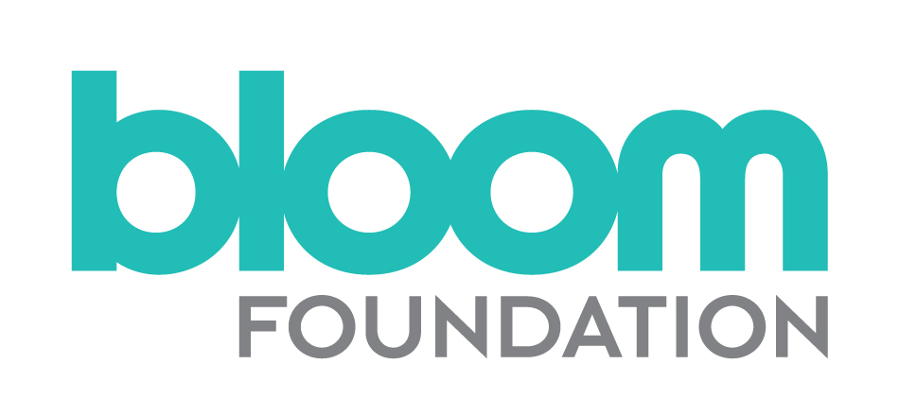

Candidate Information Pack

The Bloom Foundation (TBF)

Senior Grants Manager

Salary: £40,000–£50,000, plus generous benefits

CONTENTS

Background Briefing 2

Job Description 5

Person Specification 8
The Recruitment Process 9

Application Form (download here)
Equal Opportunities Monitoring Form (download here)

The Bloom Foundation is committed to best practice in
Equality, Diversity, and Inclusion.

For an informal discussion contact
Allyson Davies at Bloom@allysondavies-consultant.com
or call 020 7828 3855 / 07968 556164

BACKGROUND BRIEFING

About The Bloom Foundation

Founded in 2011, the Bloom Foundation is a UK-based family trust which spends on average £4.5million a year and funds a diverse portfolio of charities in the UK and Israel. The Foundation seeks to:

  - Mainstream a preventative approach to improve health, with a particular focus on research and life-style based interventions

  - Create a more cohesive society in Israel, particularly through common purpose programs and advocacy, which bring together different parts of society.

  - Strengthen the UK Jewish community and the local Brighton community through supporting key service organisations.

The Foundation is run by a small executive team (full-time Chief Executive, full-time Senior Grants Manager and full-time Charity Assistant) and there is a close and collaborative relationship with the Trustees. The Foundation team works closely together and meets regularly; they also manage their own workloads and work to tight deadlines. The Chief Executive is based in Israel and is available during working hours; she spends one week per month in the London office. The Foundation Assistant and the Senior Grants Manager are both London-based. Grant applications are brought to quarterly meetings for Trustee decisions. The team works to ensure that processes are in place to assess applications, prepare for decisions, process payments and monitor grants accordingly. There is a shared commitment to providing a professional grants programme and to being supportive to everyone who comes into contact with the Foundation.

Based within a modern office in Camden, The Bloom Foundation is co-located with a private company and benefits from shared resources and office space, including use of a gym and a café serving healthy food, both of which are available for employees of the Foundation. The culture is very friendly, flexible and hard working. Currently, there is a hybrid working form, with employees working both in the office and from home. People are valued and appreciated, and employees enjoy a sociable and relaxed environment. The business and philanthropic activities are intertwined and there is a creative flow between the two. Foundation staff are also overseeing the delivery of the corporate charity programme within the business, which includes grant making, volunteering and fundraising. The staff are highly motivated and committed to the philanthropic element of the work culture.

The Bloom Foundation’s values

TBF’s values inform its core mission of “Helping Communities Thrive,” they are:
- passionate about making a real difference
- bringing out the best in others
- acting with integrity
- effective and efficient delivery

What makes it exciting?

The Foundation is relatively new and is still forming and developing. As such there will be lots of opportunities for the Senior Grants Manager to get involved in shaping the future of the organization and helping the Foundation deliver on some exciting challenges, these include:

- Contributing to the development and delivery of strategies, policies and processes to ensure that the grants programme is creative, innovative and delivers positive outcomes.
- The Foundation gives away £4.5million per year to around 75 organizations. The Foundation’s grant-making approach is engaging over the long term with grantees, to see them deliver on their mission successfully.
- Supporting the delivery of BNJC – a new and innovative communal hub to strengthen and enhance the Jewish community living in Brighton, which will include residential accommodations, a nursery, a kosher cafe and a community and business hub.
- Supporting the development of Overcoming Multiple Sclerosis, a charity that has a close relationship with the Foundation and promotes a health and lifestyle approach to managing MS.
- Supporting the delivery of the private company’s charitable giving programme, working with company employees to guide and support the corporate charity committee.
- Helping to research and identify new potential grantees and strategic partnerships and being involved in the evolution of grant giving.
- Representing the Foundation externally, networking and building relationships to enable the Foundation’s work to be as effective as possible.

About you

The Senior Grants Manager will need to be a team player who can work collaboratively and add value to the work. They will genuinely enjoy grant making as well as have the curiosity and desire to learn and develop new areas of knowledge and expertise. They will also need to be able to demonstrate that they are interested in and committed to contributing to the success of a small organisation and will need to be versatile, flexible, with a “can do” attitude and able to contribute to the many exciting challenges ahead.

It could be the right opportunity for a range of potential candidates but whatever your motivations, The Bloom Foundation would like to hear from you, particularly if you have grant making experience, emotional intelligence and are a good communicator; you are a relationship builder, team player, flexible, proactive, strategic and analytical but also able to deliver; you are organised, have a demonstrable passion for the foundation’s work and a genuine interest in and willingness to learn about all its areas of work.

The Bloom Foundation is an equal opportunity employer and we’re proud of our ongoing efforts in creating an inclusive environment for everyone. The Bloom Foundation’s hiring process is an important part of our culture. We care about building a more representative and inclusive workplace, and that begins with hiring.
JOB DESCRIPTION

Job Title: Senior Grants Manager
Salary: £ 40–50k, plus contribution to pension and Private Healthcare and employee gym and café
Location: Camden, London
Hours: Full-time (35 hours/five days per week + possible evening events + some travel)
Contract: Permanent
Responsible to: The Chief Executive
Works with: Charity Assistant
Staff from the Private Company
Trustees
Grantees

Grants management:
- Contribute to the development and maintenance of a strong grant making process that meets the Foundation’s funding priorities.

- Researching individuals and organisations of interest to the Foundation and keeping abreast of issues in the public policy and media landscape.

- Assessing grant applications; including carrying out due diligence, financial assessment, conversations with applicants, desk research, site visits, and seeking further information as necessary. Provide recommendations based on assessment and the Foundation’s priorities and budget considerations.

- Help prepare papers for Trustee meetings and present applications to Trustees; supporting them in understanding issue areas.

- Engage with potential, new and existing grantees (in the UK and beyond) and other stakeholder to fulfill the Foundation’s mission.

- Implement the Foundation’s grants management process, from application stage to end of grant award within agreed timeframes, including: providing feedback, initiating grant payments and working on monitoring and evaluation of grants.

- Work on the Foundation’s grant monitoring activities, including site visits and reports from funded organisations, to enhance learning.

- Develop expertise and in time take responsibility for particular areas of grant-related work.

- Use the Foundation’s database (Blackbaud) for whole grant life-cycle. This includes keeping records up to date, running reports and pulling data, plus managing the online application and report forms as necessary.

- Maintain clear and accessible records of all work undertaken using agreed standards.

Relationship building:
- Develop and maintain external relationships with grantees and with other trusts and foundations with a focus on learning and improving funding programmes and processes.

- Contribute to effective team working by sharing information and skills within the Grants Team and by supporting colleagues.

- Represent the Foundation in a way that is consistent with its values and ethos and upholds its reputation at all times.

- Take responsibility for correspondence and answering applicants’ enquiries by phone and email.

- Attend internal and external events and meetings (occasionally after work hours).

Support to the Foundation and Private Company Charitable Activities:
- Work with the Chief Executive and Trustees in continuing to shape and refine the grant-making vision and practice, providing input into the Foundation’s strategies and planning.

- Processing small/discretionary donations on an ad-hoc basis.

- Contribute to Grants and Trustee Meetings as required.

- Sit on the private company’s charity committee, providing support and advice to the company’s employees in their charitable activities.

- Oversee the private company’s corporate grants programme, including guiding employees in the process of grant giving, assessing grant applications and end of grant reporting.

General:
- Offer flexible support for the work of the Foundation generally, as and when necessary. Provide cover for other members of the staff team ensuring that the work of the Foundation can continue effectively and without interruption.

- Undertake any other duties in support of the Foundation’s work as may reasonably be required.

PERSON SPECIFICATION

Knowledge, skills and experience
A strong level of intellectual and analytical ability is required.
Experience of grant making and carrying out grants assessments.
Experience of working with a grant management database system (the foundation use Blackbaud).
Interest in learning from grant making to inform future practice.
Excellent communication skills including the ability to present complex information clearly and concisely in oral and written form and to work across distances and time differences (one member of the team is based in Israel).
Ability to think strategically and able to present ideas and thinking.
Numerate and confident working accurately with figures. Experience of reading and analyzing charity accounts.
Computer literate with experience in using a range of office software packages (including MS Office and Excel).
Personal qualities and abilities
Ability to organise own workload and prioritise deadlines.
An interest in and a passion for our funding areas.
Strategic and analytical.
Empathy for and commitment to our work, grantees and core values.
Flexibility and a “can do” attitude, versatility and self-motivation, able to take decisions when necessary.
A high level of diplomacy with a high regard for confidentiality.
A self-starter and team player, able to work both independently and collaboratively.
Emotionally intelligent and good relationship building skills.
Commitment to learning and development.
Friendly, open and curious.
Enthusiastic, highly motivated and genuinely interested in the work of the Foundation.

THE RECRUITMENT PROCESS – TIMETABLE

Deadline for applications | Monday, 2 May, 2022 @ 10am
Screening interviews | 4 & 5 May
Panel interviews | 10 May
Final Interview | 13 May
Decision made & successful candidate notified | Mid-May
Background checks completed | Late-May

The successful candidate will be asked to demonstrate right to work in the UK.

To Apply
If you would like to apply for this role, please complete the Application Form and Equal Opportunities Monitoring Form (click links to download). Attach a CV outlining your career to date, with any academic and professional qualifications.

Please send these three documents, by 10am on 2 May, to Bloom@allysondavies-consultant.com

Data Protection
The personal information that you provide will be used to process your application for employment with The Bloom Foundation. Personal information about unsuccessful candidates will be held securely for 6 months after the recruitment exercise has been completed; it will then be destroyed or deleted. If your application is successful and you take up employment, the information will be used in the administration of your employment with us. It will be kept secure and will only be used for purposes directly relevant to your employment.

Information
If you require any further information or you would like to discuss anything in more detail, please contact Allyson Davies at the above email address, or call 0796 855 6164.

