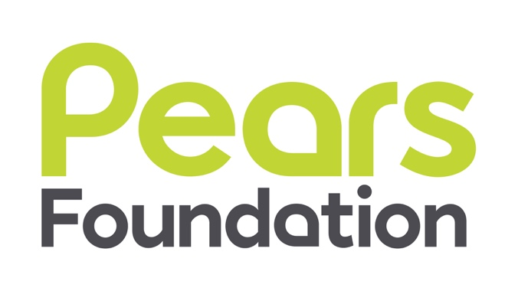

Candidate Information Pack

Foundation Administrator
£25,000 – £30,000

Contents

Background Briefing 2

Job Description 4

Person Specification 6

The Recruitment Process 7

Application Form (separate download)
Equal Opportunities Monitoring Form (separate download)

Pears Foundation is committed to best practice in
Equality, Diversity, and Inclusion.

Job-share applications are welcome.
Flexibility around working hours to enable caring responsibilities.

For background information on the Pears Foundation go to:

http://www.pearsfoundation.org.uk/
BACKGROUND BRIEFING

Are you the new Pears Foundation Administrator?
- Are you committed to working in the charity sector to help provide support to a wide range of organisations and individuals?
- Do you genuinely enjoy delivering a first-rate administrative function?
- Are you a real team player who is flexible and supportive, and who is also a self-starter and able to manage your own workload?

If so, then you might be the right person to join our small, high performing, friendly team at the Pears Foundation.

About the Pears Foundation
Pears Foundation is a family foundation driven by a desire to demonstrate the good that philanthropy can achieve in the world. We achieve this by:
- Providing core funding for essential costs
- Developing long-term relationships with our partners
- Providing more than money

A few of the many partnerships we have formed over the years include:
- Ambitious about Autism – supporting the growth, success and impact of their work with children and young people with autism
- Coram – supporting the creation of a centre for creative therapy and adoption support
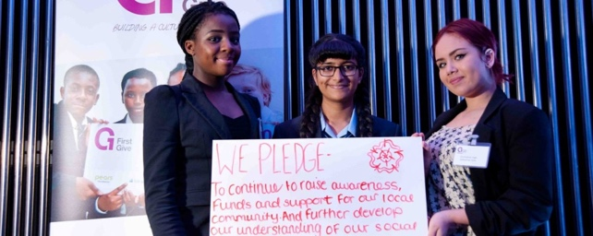
- Marie Curie – supporting the Marie Curie Nursing Service to deliver end-of-life care locally and nationally
- First Give – a programme that encourages young people to get engaged with the issues they care about and to become actively involved in charities.

We believe that thoughtful and effective philanthropy is about creating space. Space for services, space to breathe, space to work, space to reflect and spaces to innovate, explore and learn. The projects and organisations we fund reflect this approach and in addition to funding we also provide:

- The Pears Hub – an open-plan working space, with meeting rooms, breakout spaces and a separate area for coffee and lunch, for Pears Foundation grantees.
- A Professional Development Programme – we offer our grantees a changing programme of workshops and ‘lunch and learns’ as well as tailored training for individual organisations and teams.

The Foundation was established by Mark, Trevor and David Pears. Their purpose was to apply some of the resources of their family’s business, the William Pears Group, to fund organisations and projects working to deliver progress on key issues affecting the wellbeing of people in the UK and internationally. Since its establishment the foundation has committed over £250 million of support.

The Pears family, in particular our Executive Chair, Sir Trevor Pears, are at the heart of the Foundation and it is one of the few foundations in the UK to be led by a living settlor.

Based within a modern office in West Hampstead, the Pears Foundation is located in the same building as the company and benefits from shared finance, facilities, HR and IT teams. The Foundation itself is run by a small executive team that is friendly, hard working, flexible and committed to learning and development, at both an individual and organisational level as well as through its funding programme. While the team works closely together and meets regularly, they also manage their own workload and work relationally with their grantees. Funding decisions are made by the Trustees, in particular the Executive Chair, and the team works to support grantees to deliver and develop, by going on their journeys with them. We work in a committed and long-term way with our partners and have funded many of them for five and even ten years.

In line with our values of passion, professionalism and integrity, the team shares a commitment to being professional and supportive to grantees. We also seek to be supportive to everyone who comes into contact with the Foundation, whether as a partner, supplier, collaborator, visitor to the Pears Hub or an attendee at a workshop.

About the role
First and foremost, the Foundation Administrator will need to have a genuine interest in and commitment to delivering a first-class administrative function. The Foundation Administrator will be good at day-to-day administration and will take pride in doing this job well and completing tasks to a high standard. A key part of a small team, the Foundation Administrator will support colleagues, trustees and visitors to the Foundation. They will be responsible for the Pears Hub and will liaise with users. The Foundation Administrator will also be responsible for administering all the Foundation’s payments and will support the Operations Manager to refine and develop the systems and processes of the Foundation to ensure that the operations run as smoothly as possible. Overall, this role will make a valuable contribution to the work of the Foundation and will enable greater efficiency and effectiveness in our work.

The role is primarily office-based in order to support the smooth running of the Pears Hub but we will consider ways to incorporate flexible working within that.

About you
The Foundation Administrator will need to be a team player, who can work flexibly, accurately and collaboratively to add value to the work. They will need to genuinely enjoy administrative challenges and working with others to develop and deliver new systems and processes. The Foundation Administrator will also need to be confident, friendly and diplomatic with high levels of Emotional Intelligence.

It could be the right opportunity for a range of potential candidates but whatever your motivations, the Pears Foundation would like to hear from you, particularly if you: enjoy a variety of tasks and challenges, are a good communicator, are confident with finances, are a team player, are flexible, organised, and have strong attention to detail.

This is a great opportunity for someone who likes working in a small, friendly but hardworking team. Continuous learning is at the heart of the work of the Foundation, and the Foundation Administrator will need to value this too.

We value and respect all the differences that make us who we are, including
differences of: age, cultural background, disability and mental health, ethnicity and race, sex, gender identity and expression, sexual orientation, and social background.
JOB DESCRIPTION

Job Title: Foundation Administrator
Salary: £25,000–£30,000 plus 5% employer pension contribution, life insurance and Employee Assistance Programme
Location: West Hampstead (the role is office-based)
Hours: Full-time (35 hours/five days per week, with some flexibility)
Contract: Permanent
Responsible to: Director (line manager)
Operations Manager (dotted line report)
Key relationships with: Director and Pears staff
Trustees and their Personal Assistants
Other William Pears Group staff
Pears Foundation grantees

Purpose of the post:
To provide administrative support to the Foundation, working closely with the Director and the Operations Manager, ensuring that systems and processes work as smoothly as possible, that the grant-making and Professional Development Programmes are supported and that the Pears Hub is professionally managed.

General administration
- Work closely with the Director and the Operations Manager to ensure the overall smooth running of the Foundation and support the ongoing development and delivery of systems and processes, procedures and policies.
- Being the first point of contact for phone calls and enquiries, processing and managing incoming and outgoing mail, incoming telephone and email enquiries.
- Being the main contact point for suppliers and service providers, dealing with invoices and bills and ensuring that payments are processed.
- Provide support to the Director and team members when required, such as diary management, organising meetings and travel/accommodation, supporting with correspondence and documents and generally enabling the Director’s role to function smoothly.
- Responsible for the administration of payments, ensuring that they are accurate and timely.
- Provide administrative support to ensure that the Professional Development Programme is managed professionally and effectively.
- Provide administrative support on communications projects, such as the e-newsletter and website.
- Ensure that online and hard copy records are up to date and contain an accurate record in line with audit requirements.
- Ensure that the office is professionally run and act as a host for visitors and meetings, making sure that refreshments and food are available when required.
- Ensure that the office is well organised and tidy, including ordering supplies, shredding and day-to-day office clearance etc.
- Be aware of the Foundation’s GDPR policies and implement them effectively.
- Be proactive in suggesting ways of improving and automating systems and processes.

Administration for grants:
- Assist the grant managers by providing administration to a high standard across the whole grants cycle, including producing letters, administering payments to grantees, and monitoring and tracking grant reports.
- Assist in the preparation and distribution of documents for trustee meetings.
- Work with the team to ensure that grantee information is accurately kept on Salesforce.
- Keep track of grant payments and matched funding, and obtaining and uploading the necessary information for grants and payments to be made.

Pears Hub administration
- Manage the Pears Hub professionally and effectively, ensuring that the bookings diary is accurate and up to date and that users are aware of the User Guide, that the facilities are working and supplies are replenished.
- Welcome and orient users of the Pears Hub and help solve any issues that arise.

Relationship building
- Build supportive working relationships with all team members and the Executive Chair, enabling and assisting them when needed.
- Deal with telephone and email enquiries in a professional manner, redirecting or taking messages as appropriate and using initiative to deal with queries.
- Provide support to the trustees as required and help to solve issues as they arise.

Database and website administration
- Work closely with the Operations Manager to contribute to the development and upkeep of a Salesforce grant management database, working with colleagues to ensure that the database is maximized.
- Work closely with the Operations Manager to ensure that the website remains up to date and effective.

General
- Undertake any other duties in support of the Foundation’s work as may reasonably be required.
PERSON SPECIFICATION

Knowledge, skills and experience | E | D
Experience of working in or with the voluntary, charity or community sector.
Excellent administration skills, organised and efficient with good attention to detail.
Able to draft and present information clearly, accurately and appropriately in a variety of formats (e.g., letters, emails, reports).
Excellent relationship building and interpersonal skills, able to liaise well and respond to enquiries from a range of people and organisations, using email, phone, and face-to-face communications.
Good organisational skills, able to juggle a range of roles and challenges.
Good level of financial literacy and confident with numbers.
Experience of using and maintaining a database.
Accurate data entry skills, proactively updating data, whilst ensuring quality and accuracy.
Computer literate with experience and confidence in using a range of office software packages (including Word and Excel).
Experience of some financial administration.
Personal qualities and abilities
Strong communicator, able to deal in a helpful, friendly and professional manner with grantees, trustees, colleagues and all enquiries/visitors to the office.
Strong time management skills, with the ability to work well under pressure and to organise and meet deadlines.
An appetite to learn about and help develop a database and office systems generally.
A self-starter and team player, able to work both independently and collaboratively.
An ability to be diplomatic and with a high regard for confidentiality.
Friendly, supportive and enabling.
Enthusiastic, motivated and genuinely interested in the work of the Pears Foundation.

THE RECRUITMENT PROCESS – TIMETABLE

Deadline for applications | 5:00pm on Thursday, 24 March, 2022
Screening interviews | ongoing
Panel interviews | 28 March
Final Interview (if required) | 30 March
Decision made & successful candidate notified | 31 March

Following interview, the successful candidate will be asked to demonstrate their right to work in the UK and go through Basic DBS checks.

How To Apply
If you would like to apply for this role, please complete the Application Form and Equal Opportunities Monitoring Form (downloaded from the ad on http://www.allysondavies-consultant.com/job-board/foundation-administrator-pears-foundation/), and attach a CV outlining your career to date, with any academic and professional qualifications.

Please send these three documents, by 5pm on Thursday, 24 March, 2022, to
pears@allysondavies-consultant.com

Note to Job-share Applicants
Job-share applications are welcome. Please make it clear on your application if you are applying with a potential job-share partner.

Data Protection
The personal information that you provide will be used to process your application for employment with the Pears Foundation. Personal information about unsuccessful candidates will be held securely for six months after the recruitment exercise has been completed; it will then be destroyed or deleted. If your application is successful and you take up employment, the information will be used in the administration of your employment with us. It will be kept secure and will only be used for purposes directly relevant to your employment.

Information
If you require any further information or you would like to discuss anything in more detail, please contact Allyson Davies at the above email address, or call 07968 556 164.

