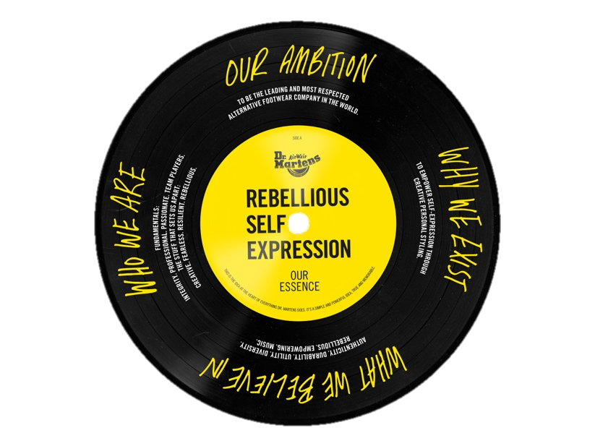
Dr Martens, Foundation Manager

Salary: £50,000-£60,000
Reports To: Sustainability Manager
Location: Camden
Hours: Full-time
Contract: Permanent

DR. MARTENS

Dr. Martens is an iconic global brand and one of the most recognised footwear brands in the world, selling over 12 million pairs annually in more than 60 countries. Globally there are 135 stores and the company employees 2232 people. We are growing rapidly and our revenue last financial year was £773 million. We operate a regional model from three regions: EMEA (headquartered in London), the Americas (headquartered in Portland) and APAC (headquartered in Hong Kong), with its head office in the UK.

The brand is a canvas for rebellious self-expression across generations and is adopted by a broad and diverse range of wearers who identify with the brand’s spirit of rebelliousness and resilience and adopt the boots to suit their own style. This attitude goes across cultures, ages, genders and social classes.

THE FOUNDATION

This year, the Dr. Martens Foundation became an independent UK registered charity. As part of the recent Initial Public Offer of the business, shareholders donated substantial funds to the Foundation. The mission will be focussed on social justice, inclusion and equality but we don’t want to be run of the mill, we really want to stand up in the world and support those working for social justice and change.

Our vision is to create an impactful and lasting Foundation that works both in the UK and internationally. We want the Foundation to be as identified with social justice as DM’s boots are with rebellious spirit. Everyone involved wants the Foundation to build a legacy and make a real difference through its activities and grants. Across DMs, employees are really excited about the Foundation: they want to be involved and to give something back and there is a real enthusiasm to get things going. In order to achieve all of this we need you to step in…

THE GIG
The Foundation Manager will be the first full-time team member of our newly established Foundation. They will step up and enable the Foundation to get its activities off the ground and act as a bridge between the company and the Foundation to enable the teams to engage, support and participate in the work of the Foundation. They will be key in the journey towards creating a Foundation that will exist for many decades to come, which will include:
- Establishing and building a grant-giving programme that will support organisations and groups to do work which furthers the aims of the Foundation
- Establishing and building flagship partnerships with organisations that we will support with significant, strategic, multi-year funding
- Building opportunities for the team to contribute to growing the foundation through getting involved through employee giving, galvanising voices for social justice movements, or interest in the grants we give and partnerships we build
- Working collaboratively with trustees, keeping them informed and enabling them to be able to make decisions around our philanthropic activities

THE STUFF THAT SETS YOU APART
- Demonstrable experience in building creative funding partnerships
- Amazing relationship building and networking skills
- A flexible, proactive and innovative mindset and an ability to surf the waves and persevere
- Strong skills and experience in creating and implementing systems and processes
- Experience of working creatively, and of developing and establishing new ideas and initiatives
- Good understanding and knowledge of grant making, preferably with some international experience and insight
- Passion, knowledge and experience around social justice issues and ED&I
- An enjoyment of work and an ability to have fun
- Knowledgeable about and experienced in working with issues around charity governance and management
- Solid project management skills

THE STUFF THAT SETS US APART

CREATIVE… We add to this world. We make things happen. We add flair. We explore.
FEARLESS… We rise to a challenge. We step out of our comfort zones. We stand up for what we believe in.
RESILIENT… We take knocks and bounce back. We dust ourselves off. We prove ourselves. We stick to a task and see it through. We can always be counted on.
REBELLIOUS… We do things differently. We challenge conventional “wisdom”. We don’t follow. We put things out there. We ask what if? We provoke debate.

YOUR FUNDAMENTAL QUALITIES

It’s never just a job at Dr. Martens and we don’t want it to be just a job for the foundation employees either. It’s a way of life. We live and breathe our Fundamentals — INTEGRITY. PROFESSIONAL. PASSIONATE. TEAM PLAYERS. These define who we are and how we get the job done. We believe each role is as unique as the person who does it.

To be our Foundation Manager you will also possess these qualities:
- Strong communication and influencing skills
- The ability to connect and partner with international teams
- A passion for our values and the vision for our foundation
And your professional capability will go hand in hand with:

- Your great relationship management that delivers results through effective teamwork
- You being a proud custodian of our culture, embodying what we stand for and encouraging others to do the same
- You helping to build a highly engaged team — ensuring a collaborative culture and providing guidance & support to other team members
- You taking ownership of your own development, proactively seeking out feedback to build self-awareness
- You bringing the outside in: you’ll share best practice across the team/business and encourage the sharing of ideas as well as collaborative problem solving
- You leading the way and role modelling on all things DE&I and wellbeing

THE FUNDAMENTALS

INTEGRITY…We’re fair. We do things the right way. We don’t cut corners. We’re good to each other.
PROFESSIONAL…We have high standards. We lead our field. We’re proud of our heritage. We push things forward. We show the way.
PASSIONATE...We have fire in our bellies. We have drive. We care about our work. We don’t do things by half. We throw ourselves into the task at hand.
TEAM PLAYERS…We look for and play to each other’s strengths. We work together. We take responsibility. We seek and share responsibility.

HOW TO APPLY
You’ll need to download the application form and EO monitoring form, from this link:
Dr. Martens Foundation Manager. Send the completed forms, with your CV, to drmartens@allysondavies-consultant.com.
The deadline is 10am on 27th September 2021
Screening interviews will take place in early October and panel interviews in mid-late October.

