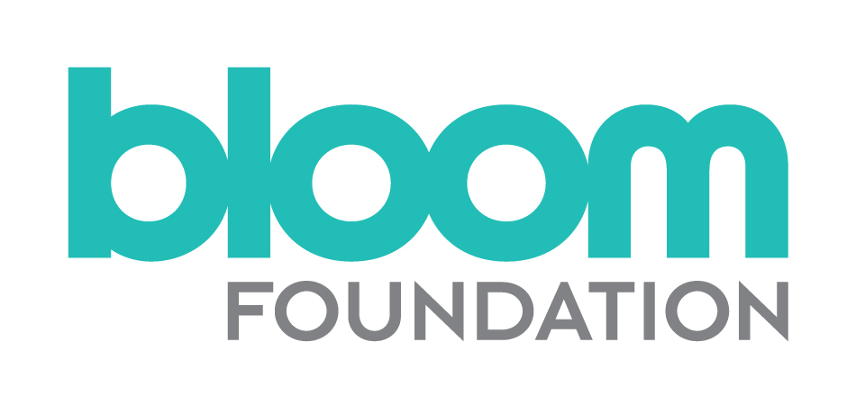
Application Form – Senior Grants Manager
Please complete this Application Form and the Equal Opportunities Monitoring form and attach a CV outlining your career to date, including any academic and professional qualifications. Send these three documents by 10am on 14 February, 2020, to Bloom@allysondavies-consultant.com
If you require any further information or would like to discuss anything in more detail, please contact Allyson Davies: Bloom@allysondavies-consultant.com or call on 020 7828 3855/07968 556 164.
Full name
Address
Mobile phone
Home phone
Email
How did you hear of this post?
Are you eligible to work in the UK?

Please give details of two professional referees: your current or most recent employer, and a previous employer:
Details required | Referee One | Referee Two
Name
Organisation
Professional relationship to you
Telephone
Email
OK to approach?

Please give details of your current income and notice period:
Basic annual salary
Notice period

On no more than two pages, please state below:
- Why you would like to be the Senior Grants Manager?
- The three key areas of experience and skills you can bring to this role?

Declaration
I declare that the information that I have provided on this form is true and accurate, and in particular that I have not omitted any fact which may have a bearing on my application. I understand that any subsequent contract of employment with the Bloom Foundation will be made on the basis of the information I have provided. I understand that a false declaration, which results in my appointment to the Bloom Foundation, will render me liable to dismissal without notice. I also understand that submitting this form electronically is equivalent to a signed declaration.
Signed [type your name]:
Date:

