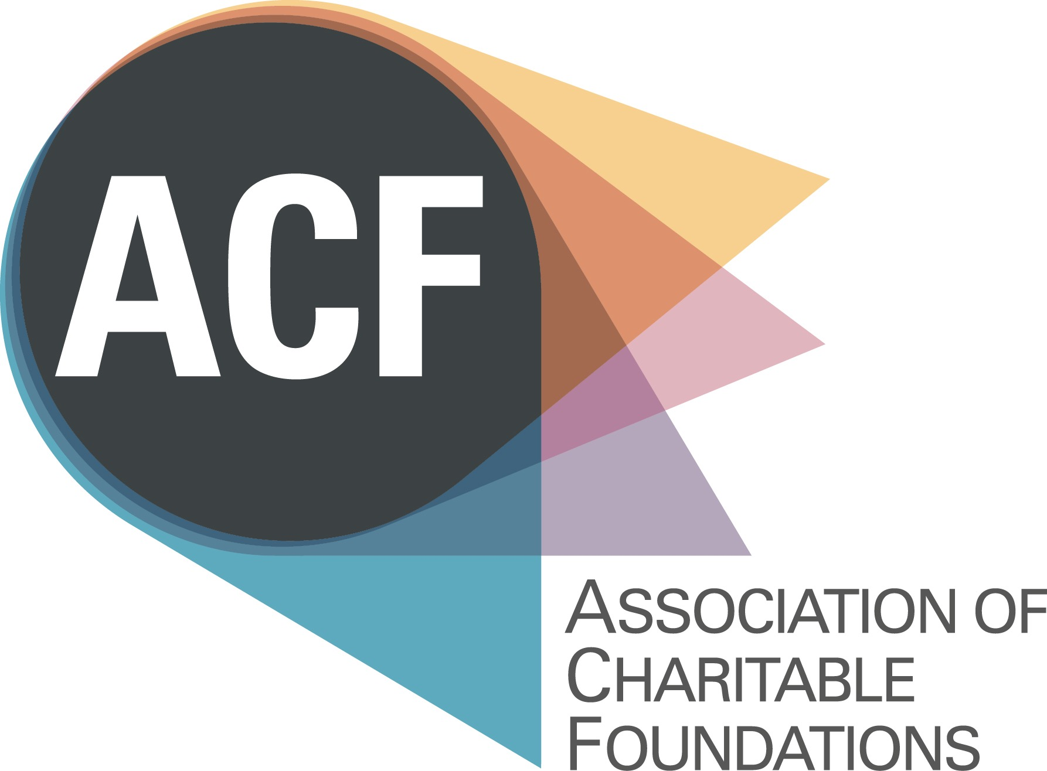

Candidate Information Pack

Policy and Communications Officer

Please find enclosed:

Background Briefing

Job Description and Person Specification
- Application Form
- The Recruitment Process
- Equal Opportunities Monitoring Form

For background information please go to:- www.acf.org.uk
Background Briefing

Why Join Us?
Would you like to work in a focused and dynamic organisation that is working on behalf of an irreplaceable social asset?

Charitable foundations are a vital force for social good. At their best, they are the most transparent, intentional and efficient way of transforming private wealth into public benefit. Since the 11th Century, they have embodied the belief that things can be better - mobilising funding, resources and expertise in the service of supporting others, whether by preserving social good that is under threat or catalysing it where it is absent.

Comprising a small, dedicated and ambitious staff team, ACF’s work sits at the intersection of private capital and public good, existing to support grant makers in their practice though the provision of information, advocacy and learning. More than ever ACF is looking to increase its influence and its impact, through the delivery of first class communications, robust policy interventions and nuanced thought leadership. The Policy and Communications Officer will play a key role in helping us to further unlock the potential and impact of these two areas of our work.

ACF
The Association of Charitable Foundations (ACF) is the membership organisation for independent charitable grant-making trusts and foundations in the United Kingdom. ACF’s membership of 330 organisations, collectively holds £25 billion in investments and assets; and gives over £1.7 billion every year to a diverse range of organisations and people: from community groups, charities and social enterprises to museums, hospitals and schools. ACF has supported trusts and foundations for 25 years; respecting and safeguarding their independence, and helping them to be effective in the multiple ways that they use their resources. Some of the key ways in which ACF supports its members are:- developing and enabling policy and communications initiatives; providing opportunities for learning and discussion; sharing knowledge and best practice and providing events and professional development opportunities.

Organisational context
Following consultation with our membership, a 2013 Strategic Plan has set out an exciting and ambitious programme which is transforming ACF, and has helped its annual turnover to reach close to £1 million. As we deliver a step change in the level of support that we provide to our members, ACF is building on its strong reputation and is becoming increasingly strategic, influential and proactive – whilst maintaining the principle of mutuality in our relationship with members. Over the past two years we have undertaken a significant step change by growing our experienced staff team and developing our programmes of activity in:- Communications, Learning and Events, Policy and Resources.

Policy and Communications at ACF
The policy and communications programmes constitute an important part of ACF’s remit and output. They have been developed significantly to be more proactive and externally engaged. Our policy work produces first rate research and thought leadership pieces on the foundation world. As well as working both proactively to develop on-going dialogue with key officials in Whitehall and reactively by responding intelligently, from a strong research base, to consultations and government led policy initiatives. Our communication programme is integral to our work and maximises our impact by developing and disseminating information both to our membership and to wider audiences. We do this using a range of communications tools:- our website; publications; research reports; articles; briefings and social media. In the last two to three years these programmes have delivered a range of highly successful initiatives, including:-

- A new website and successful rebranding project
- A research report entitled The Governance and Management of Endowed Charitable Foundations.
- Increased presence and coverage in a range of media on issues concerning foundations.
- A joint publication with Schroders entitled, For Good and Not for Keeps – how long-term charity investors approach spending on their charitable aims.
- An important publication on ethical and responsible investment Intentional Investing
- The Government’s ‘Lobbying’ Bill

However, we know that more can be achieved if we use the resources of both programmes even more creatively and effectively. Especially, if the work of the two programmes, already in a close dialogue, are brought into an even closer relationship and the synergies between the two are identified earlier, planned for and the potential impact maximized even further. In short, we aim to be even more intentional and conscious about our coordination of the two areas of work so that they add even greater value.

The role
The role offers the opportunity for someone to play a pivotal and progressive role at ACF and amongst the UK’s trusts and foundations. The challenges and opportunities are manifold, including:-

- Working collaboratively and diplomatically both internally and externally.
- Coordinating, project managing and helping to maximise the work of two senior managers.
- Enabling the policy and communications work to grow even further.
- Being in a rare position to make a high-profile contribution to the world of foundations and trusts.
- Building a relationship of mutual trust and exchange with ACF’s members and other external organisations.
- Building expertise and skills in both policy and communications for this unique and fascinating part of the charitable sector.

The person
In order to achieve our vision and goals for our Communications and Policy programmes we need to recruit a team player who will add value to work. They will need to demonstrate strengths around:- having strong writing skills; being really curious and able to quickly grasp complex issues and know how to turn events and opportunities into practical and helpful policy and communications interventions. For example, by drafting a blog for the website; or proposing an idea for a tweet; or showing initiative by being able to quickly pull together a number of responses to help shape and inform a reactive piece of policy work. The workload will be challenging, sometimes reactive and quick and other times planned and proactive. One thing you can be sure of is that it will be varied and challenging. All this means that you will need to be political and news savvy as well as being flexible, bright and able to keep a cool head and a sharp mind but we also have fun and enjoy our work and have a strong team spirit, so being able to roll your sleeves up and have a sense of humour are also important. Some experience of working in a policy and/or communications setting will be useful. However, most importantly, you will be able to demonstrate that you’ve got the potential to get to grips with the remit and that you have lots of initiative and an aptitude for our work.

Location
The post will be based at ACF’s office in Kings Cross, London.

Salary and hours
Salary: c.£26,000
Hours: Full time
Contract type: Permanent.

JOB DESCRIPTION

Job Title: Policy and Communications Officer

Works to: Head of Communications (line manager)
and Head of Policy

Purpose of the post: To support the policy and communications programmes of ACF and enable increased coordination between the two in order to maximise impact.

Coordinating Projects and Work Plans

- Managing Coordinating a range of communications and policy projects, including, timetabling projects; planning for delivery; managing milestones; liaising and informing others regarding changes to projects; keeping projects on track; etc.

- Working with the Head of Communications and the Head of Policy to plan ahead and maximise the impact of both programmes and identifying opportunities to enhance ACF’s profile by enabling and coordinating joint projects and initiatives and building the synergies between them.

Administration and Deputising

- Providing administrative support to the Head of Communication and the Head of Policy to enable both remits to achieve their potential.

  - Deputising Attending meetings and fielding enquiries on behalf of the Head of Communications and the Head of Policy when required.

- Providing administrative support for policy and communications meetings (which do not fall under the Events remit):- booking rooms; liaising with participants; diarising; organising refreshments; taking minutes etc.

Communications

- Horizon scanning the press and media to identify news which may be of interest to the membership and liaise with colleagues to disseminate stories of interest. Including creating copy and re-writing stories to appeal to members.

- Commissioning and generating content for various communications tools:- website, publications, social media, newsletters etc.

- Writing, copyediting, editing and proofreading communications outputs.

- Managing Coordinating the website; maximising its potential as a key communications outlet and shop window for ACF.

- Managing Coordinating ACF’s social media; maximising its potential and proactively developing our profile using tools such as Twitter; blogs etc.

Policy

- Researching, coordinating and supporting the production of policy publications and other policy initiatives.

- Providing the secretariat, including minute taking, to the Policy Reference Group (a group of trustees).

- Enabling the policy work by facilitating routine communications for the Head of Policy and coordinating and drafting policy responses.

- Coordinating policy initiatives such as policy consultations from government departments, including: managing the timetabling of responses; developing responses and ensuring that deadlines are met.

- Keeping a watching brief for government initiatives which may have an impact on foundations and disseminating policy bulletins on issues, with an angle on the foundation sector.

Relationship Building

- Build strong working relationships with members and other interested parties to coordinate the policy and communications, commission contributions and disseminate output.

- Fielding media enquiries and working with others to proactively engage the media when required.

Researching and Analysing

- Supporting policy and communications initiatives at the development and research stage by researching a range of issues and topics.

- Providing analyses and summaries of research findings and information in a way that is informative and useful for policy and communications purposes.

Supporting the work of ACF

- Ensure that the principles of equality and valuing diversity underpin the execution of the responsibilities and tasks described above.

- Have regard to environmental good practice in all areas of the work.

- Undertake any other duties in support of ACF’s work as may reasonably be required.

PERSON SPECIFICATION
Policy and Communications Officer

Knowledge, skills and experience | Essential | Desirable
- Experience of working in or with the voluntary and community sector.
- Experience of coordinating projects and initiatives in a co-operative way.
- Excellent communication skills. Able to write in an interesting, accurate and informative way.
- Experience of analysing and communicating complex information in a readily accessible way.
- Good administrative and organisational skills with a strong attention to detail.
- Strong IT and digital skills with experience of managing websites; twitter; blogs etc.
- Strong numeracy and research skills.
- Experience of working in a policy and/or communications setting.
- A confident self-starter with the skills and diplomacy to manage upwards and sideways.
- Genuine value of and commitment to ACF’s aims, core values and the role it plays.

Personal qualities and abilities
- Excellent interpersonal skills, able to deal in a helpful, friendly and professional way with people from different backgrounds and at varying levels of seniority.
- A team player, able to work both independently and collaboratively in the role and able to roll your sleeves up.
- Enthusiastic, highly motivated and genuinely interested in, curious about and supportive of the work of foundations.
- Able to work at the planning level and also to pay attention to detail.
- Politically intelligent and aware, an ability to understand subtlety, nuance and the need for balance.
- Genuinely interested in socio-economic issues and how society works, changes and develops and the role that foundations play in society
- An ability to identify and share stories and issues which are of interest to foundations.
- Diplomatic, articulate and persuasive.
- Ambitious as an individual but also for the work of the team and ACF generally.
- Well organised, with the ability to work well under pressure and meet deadlines and manage others to ensure that projects are delivered.
- A good relationship builder, able to develop the post and play a key role in enabling the policy and communications remits to fulfil their potential.
- Commitment to implementing equality and diversity policies, empathy for and commitment to ACF’s aims and core values, and assisting ACF in delivering its commitment to being a more environmentally responsible organisation.
- Highly developed sense of personal integrity, discretion and high standards.

Association of Charitable Foundations

Application Form

POLICY AND COMMUNICATIONS OFFICER

Please complete this Application Form and Equal Opportunities Monitoring Form (delete the first seven pages of this document), and attach a CV outlining your career to date, plus any academic and professional qualifications. Please send your application, by 10am, on 24 May 2016, to acf@allysondavies-consultant.com

Full Name:
Address:
Mobile Phone:
Home Phone:
Email:

How did you hear of this post:

Are you eligible to work in the UK?

References

Please give details of two professional referees: your current or most recent, and a previous employer:

- Name and professional relationship to you:
Tel:
Email:
OK to approach Yes/No
- Name and professional relationship to you:
Tel:
Email:
OK to approach Yes/No

Please give details of your current income and benefits details:

Basic Annual Salary: Annual Leave:
Pension: Employer contribution: Employee contribution:
Any other benefits:
Notice required:

On no more than two pages, please state:

1) Why you would like to be the Policy and Communications Officer at ACF?

2) What three key areas of your experience and skills you can bring to this role?

(please draw upon the Person Specification to inform your answer)

DECLARATION

I declare that the information that I have provided on this form is true and accurate, and in particular that I have not omitted any fact which may have a bearing on my application. I understand that any subsequent contract of employment with the ACF will be made on the basis of the information I have provided. I understand that a false declaration, which results in my appointment to ACF, will render me liable to dismissal without notice. I also understand that submitting this form electronically is equivalent to a signed declaration.

Signature ____________________________

Date _______________________________

Policy and Communications Officer

The Recruitment Process

Timetable

Deadline for applications | 24 May 2016, at 10am
Panel interviews | 31 May
Final Interview | 1 June
Decision made & successful candidate notified | Early June

To Apply

If you would like to apply for this role, please complete this Application Form and Equal Opportunities Monitoring Form (downloaded from
http://www.allysondavies-consultant.com), plus attach a CV outlining your career to date, with any academic and professional qualifications.

Please send your application, by 10am, on 24 May 2016, to
acf@allysondavies-consultant.com

Information

If you require any further information or you would like to discuss anything in more detail, please contact Allyson at the above contact details, or call 020 7828 3855 or 0796 855 6164.

