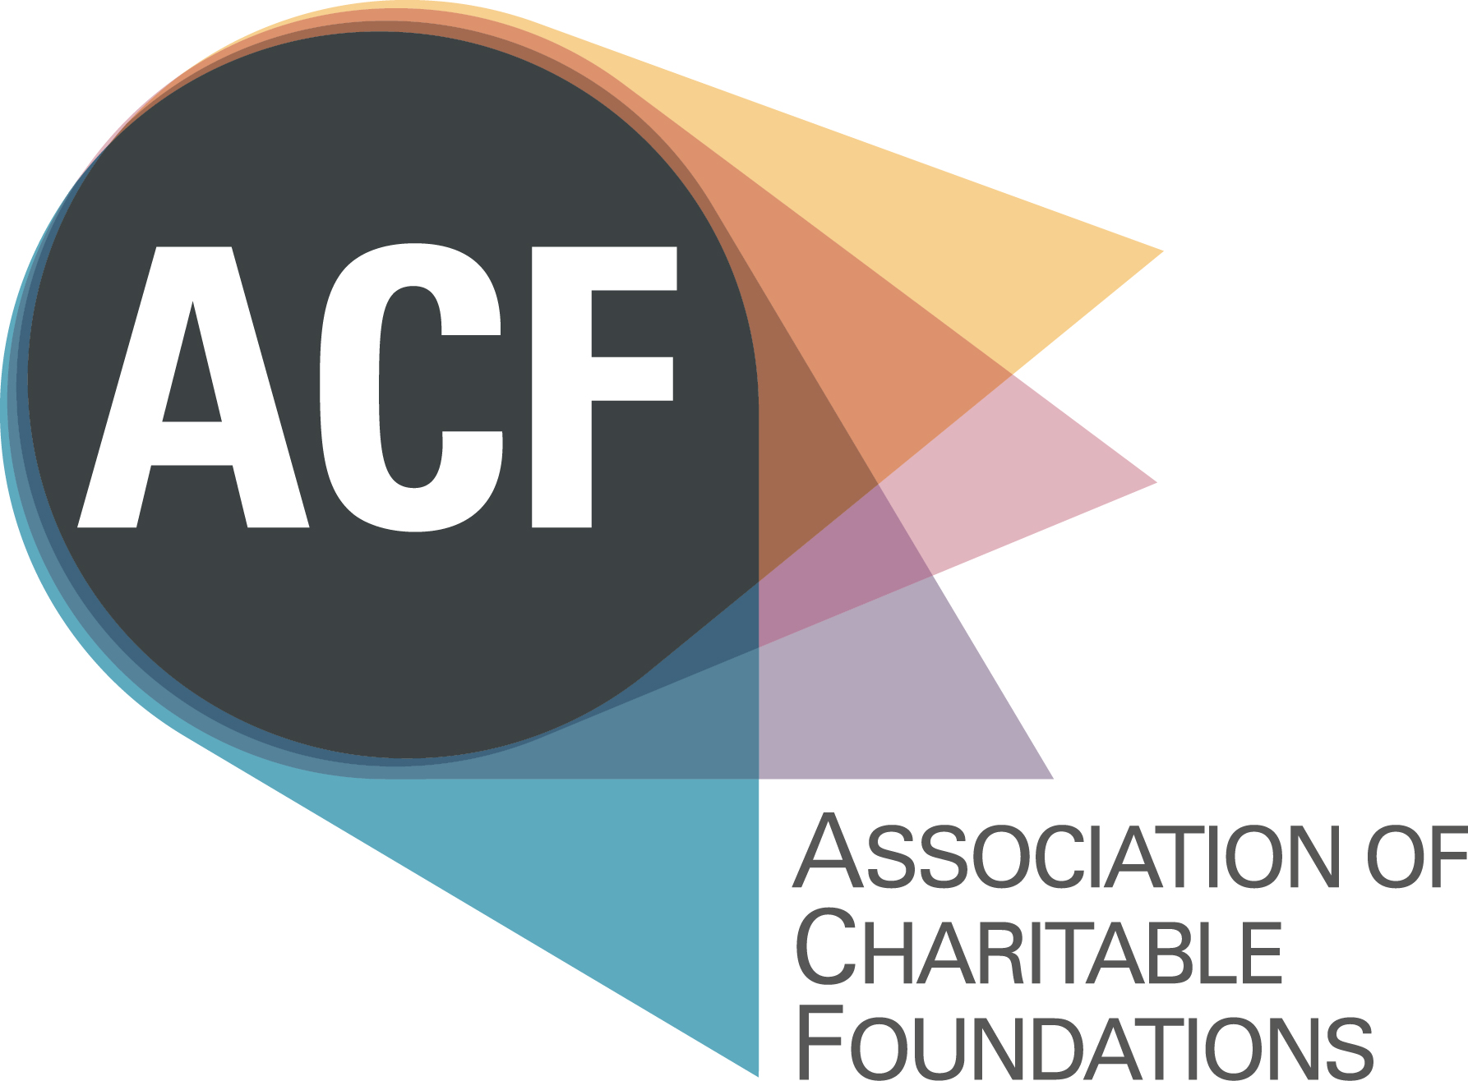

Candidate Information Pack

Head of Resources

Please find enclosed:

Background Briefing

Job Description and Person Specification
- Application Form
- The Recruitment Process
- Equal Opportunities Monitoring Form

For background information on ACF please go to www.acf.org.uk
Background Briefing

ACF
The Association of Charitable Foundations (ACF) is the membership organisation for independent charitable grant-making trusts and foundations in the United Kingdom. ACF’s membership of 330 organisations, collectively holds £25 billion in investments and assets; and gives over £1.7 billion every year to a diverse range of organisations and people: from community groups, charities and social enterprises to museums, hospitals and schools. ACF has supported trusts and foundations for 25 years; respecting and safeguarding their independence, and helping them to be effective in the multiple ways that they use their resources. Some of the key ways in which ACF supports its members are:- developing and enabling policy and communications initiatives; providing opportunities for learning and discussion; sharing knowledge and best practice and providing events and professional development opportunities.

Organisational context
Following consultation with our membership, a new Strategic Plan has set out an exciting and ambitious programme which is transforming ACF, and has helped its annual turnover to reach close to £1 million. As we deliver a step change in the level of support that we provide to our members, ACF is building on its strong reputation and is becoming increasingly strategic, influential and proactive – whilst maintaining the principle of mutuality in our relationship with members. Over the past two years we have grown our experienced staff team with the appointment of a Head of Communications, Head of Learning and Events, and a Head of Policy. The role of Head of Resources will complete this senior management team and will provide vital, strategic resource management to enable and support the delivery of our strategic goals.

The role
The Head of Resources has the opportunity to play a key role and while ACF’s financial structure is not overly complex, the challenges are manifold and our operating environment unique:
- Being an integral part of the senior team to ensure that financial management becomes part of the organisation’s culture and that managers take responsibility for their own budgets
- Having a strategic overview of the resources of ACF and enabling the organisation to deliver its strategic aims
- Taking responsibility for building personable and collaborative working relationships and really adding value to ACF

The person
This is an opportunity to have a positive impact at ACF. The Head of Resources will need to be an experienced financial professional who enjoys a broader role, adding value by also taking responsibility for the HR, H&S and IT functions. They will enjoy building strong working relationships, they will be diplomatic and able to build the role to become a trusted advisor to both staff and trustees. The Head of Resources will need to be interested in the role of trusts and foundations, and of their unique position in civil society. They will need to be able to demonstrate experience that will enable them to provide a senior perspective on financial strategy and management, as well as the potential to take responsibility for ACF’s HR, Health and Safety and IT.

Location
The post will be based at ACF’s office in Kings Cross, London.

Salary and hours
Salary: 47,000 - 50,000 FTE, depending on experience.
Hours: 21 hours spread over a minimum of 3 days a week.

Contract type
Permanent contract.

JOB DESCRIPTION
HEAD OF RESOURCES

Job Title: Head of Resources

Responsible to: The Chief Executive

Direct reports: Part-time Bookkeeper

Purpose: To work with the Senior Management Team to build a strategic resource management function in order to enable ACF’s strategic aims and objectives.

To provide advice, analysis and assistance to ACF’s Trustee Board, providing expertise on financial strategy, planning, budgeting, financial reporting and taxation.

Terms: This post is part-time, 3 days per week.

Strategy and Planning

Be a key liaison person with the Trustee Board and contribute at board meetings by supporting proposals and presenting performance against budgets

Oversee the annual budgeting & financial planning process

Be responsible for the establishment of a customer-focused culture within the finance function

Contribute to the achievement of ACF’s Strategic Plan by developing a resource strategy that will enable the goals and aims to be delivered

Be responsible for statutory reporting, consolidation and the audit process and ensuring compliance with all applicable laws and regulation

Ensure that ACF is service oriented, focused on providing stakeholders with a value-adding, cost-effective service

Financial Management

Direct and manage all of ACF’s financial activities from the strategic to the day-to-day finances

Produce the Trustees Annual Report and Financial Statements in compliance with UK GAAP and the Charity SORP and liaise with the external auditors to complete the annual audit

Ensure that financial reports are accurate, timely, and relevant and that KPIs are developed and monitored

Ensure that ACF’s financial systems, procedures and controls meet organisational needs and are compliant

Prepare a rolling twelve month forecast of Income & Expenditure and Cash flow

Manage the ACF treasury

Identify, monitor and manage financial risks

Liaise with bankers, pension advisors, auditors, HMRC, the Charity Commission etc. as required

Keep up to date with good financial practice

Human Resource Management

Take lead responsibility for the Human Resource management, ensuring that policies, procedures and systems are compliant with legislation

Ensure that staff contracts are issued and kept up to date

Take lead responsibility for updating the staff handbook

Liaise with HR advisors where appropriate to ensure that best practice is followed

Keep up to date with good HR practice

Health and Safety Management

Take lead responsibility for Health and Safety management, ensuring that policies, equipment, procedures and systems are compliant with legislation

Keep up to date with good H&S practice

Information Technology

Take lead responsibility for IT management, ensuring that the IT infrastructure is up to date and enabling of the deliver of ACF’s strategy

Research and introduce new IT solutions to ACF, such as video conferencing

Trouble shoot IT problems where possible and liaise with IT support and providers

Relationship Building

Manage and motivate a Bookkeeper, ensuring that their work is accurate and delivered to time

Collaborate with the other senior managers to ensure that ACF’s financial management is integrated into the culture of the organisation

Support managers on effective budget management and where needed provide coaching and guidance on finances

Build positive relationships with the staff, the board of trustees, especially the Honorary Treasurer and with ACF’s members

Be responsible for relationships with contractors for equipment and services

Supporting the work of ACF

- Ensure that the principles of equality and valuing diversity underpin the execution of the responsibilities and tasks described above

- Have regard to environmental good practice in all areas of the work

- Undertake any other duties in support of ACF’s work as may reasonably be required

PERSON SPECIFICATION
HEAD OF RESOURCES

Knowledge, skills and experience | Essential | Desirable
- Experience of working in or with the voluntary and community sector. |  | ✓
- CCAB qualified (member of one of the UK accountancy bodies) | ✓
- Strong administrative and organisational skills | ✓
- Strong communications skills and the ability to clearly explain financial management issues to all staff | ✓
- Sound competence in the use of the office systems relevant to fulfilling the responsibilities of the post (i.e. Financial software, Windows-based word processing, spreadsheet software, CRM database etc.) | ✓
- Experience of the Charity SORP |  | ✓
- Empathy for and commitment to ACF’s aims and core values | ✓
- An interest in the work and environment of charitable grant-making trusts and foundations | ✓
- Understanding and experience of a financial functions | ✓
- Experience of overseeing HR, H&S and IT |  | ✓
- Experience of managing the audit process | ✓
- Ability to analyse and organise data in a way that provides information and insight to both financial and non-financial managers | ✓

Personal qualities | Essential | Desirable
- Excellent interpersonal skills, able to deal in a helpful, friendly and professional way with people from different backgrounds and at varying levels of seniority. | ✓
- Ability to work both independently and collaboratively | ✓
- Willing and motivated to become a team player and advisor to the trustees and staff on resource related matters | ✓
- Able to work at the strategic level and also to pay attention to detail | ✓
- Well organised, with the ability to work well under pressure and meet deadlines. | ✓
- Commitment to implementing equality and diversity policies, empathy for and commitment to ACF’s aims and core values, and to assisting ACF in delivering its commitment to being a more environmentally responsible organisation | ✓
- Highly developed sense of personal integrity. | ✓

Association of Charitable Foundations

Application Form

HEAD OF RESOURCES

Please complete this Application Form [delete the preceding pages before sending], and attach a CV outlining your career to date plus any academic and professional qualifications. Please send your application, and the completed Equal Opportunities Monitoring Form (download this from http://www.allysondavies-consultant.com/job-board/equal-opportunities-monitoring-form/) by 10am, on 9 July 2015, to acf@allysondavies-consultant.com

Full Name:
Address:
Mobile Phone:
Home Phone:
Email:

How did you hear of this post:

Are you eligible to work in the UK?

References

Please give details of two professional referees: your current or most recent, and a previous employer:

- Name and professional relationship to you:
Tel:
Email:
OK to approach: [ ] Yes [ ] No
- Name and professional relationship to you:
Tel:
Email:
OK to approach: [ ] Yes [ ] No

Please give details of your current income and benefits details:

Basic Annual Salary: Annual Leave:
Pension: Employer contribution: Employee contribution:
Any other benefits:
Notice required:

On no more than two pages, please state:

1) Why you would like to be the Head of Resources at ACF?

2) What three key areas of your experience and skills you can bring to this role?

(please draw upon the Person Specification to inform your answer)

DECLARATION

I declare that the information that I have provided on this form is true and accurate, and in particular that I have not omitted any fact which may have a bearing on my application. I understand that any subsequent contract of employment with the ACF will be made on the basis of the information I have provided. I understand that a false declaration, which results in my appointment to ACF, will render me liable to dismissal without notice. I also understand that submitting this form electronically is equivalent to a signed declaration.

Signature ____________________________

Date _______________________________

The Recruitment Process

Timetable

Deadline for applications | 9th July 2015 at 10am
Screening Interviews | 14, 15 and 20 July
Panel interviews | 29 July
Final Interview | 31 July
Decision made & successful candidate notified | Early August

To Apply

If you would like to apply for this role, please complete this Application Form [delete the preceding pages before sending] and the Equal Opportunities Monitoring Form (from http://www.allysondavies-consultant.com/job-board/equal-opportunities-monitoring-form/), and attach a CV outlining your career to date plus any academic and professional qualifications.

Please send these three documents, by 10am, on 9 July 2015, to
acf@allysondavies-consultant.com

Information

If you require any further information or you would like to discuss anything in more detail, please contact Allyson at the above contact details, or call 020 7828 3855 or 0796 855 6164.

